Knowledge Sharing Report

Labour and Accommodation – Nyngan Solar Plant

Project Name: | AGL Energy Solar Project (Nyngan Solar Plant)

Knowledge Category: | Logistical
Knowledge Type: | Human Resources

KEY LEARNING

The construction of utility scale solar project involves a significant amount of skilled and unskilled labour. Site locations in regional areas such as Nyngan are not always able to meet the full labour requirements and non-local labour must be sourced to add to the local workforce.

IMPLICATIONS FOR FUTURE PROJECTS

It is important that project planning and cost estimates factor in the availability of skilled and unskilled workers within the project area. If the project will require specialised trades in addition to those that can be sourced within the local area, then consideration must be given to the following issues:
- An estimate of the quantity and duration of non-local workers required for the project;
- A search for the most suitable source of non-local workers and the likely mode of transport to the project area;
- A thorough investigation of the local accommodation alternatives, including hotels, motels, caravan parks and residential dwellings; and
- Evaluation and costing of new or temporary accommodation to host the non-local workers.
Whilst the cost of labour in regional and remote towns is similar to those in the capital cities, where additional labour from outside the project region is required, it will be necessary to provide local accommodation and mess services which will increase project cost. Sourcing non-local labour will also impact the local community, which must be consulted to optimise the economic benefit while minimising impacts on community amenity.
To the extent that skills in and knowledge of utility-scale solar become concentrated in a relatively small fly-in fly-out labour pool rather than more broadly disseminated throughout communities and regions, this may delay or impair the uptake and acceptance of large-scale solar in Australia.
It is important that local governments play a role in identifying local labour conditions and community views/preferences on accommodation alternatives. Some communities encourage temporary accommodation facilities to be established outside the town to minimise disruption, while others may prefer the facilities to be within the town area so that the economic benefits can flow directly to local businesses. Local hotel/motel operators also have a range of opinions on long term tenancies, balancing the security of a long term room booking with the desire to have some availability to host tourists and travellers. These preferences will be site specific and local government should be encouraged to represent the views of communities.

KNOWLEDGE GAP

First Solar has provided on-site skills training to site workers to build local solar construction capacity. In addition, First Solar’s engineering and procurement team has worked with local fabricators to modify First Solar’s standard global designs to meet local design requirements. Additionally, a collaboration between IXL, the company involved in producing structural components for the project, and OMCO, First Solar’s supplier to similar projects in the USA, has provided knowledge and skills transfer opportunities.
BACKGROUND
Objectives or Project Requirements

The Nyngan project will require a workforce of up to 250 people at peak construction, which will comprise a mix of functions including project management, engineering, quality, safety, project controls, supervisors, trades, administration and unskilled labour. The workers will be employed though a number of companies, including the prime contractors, subcontractors and labour hire agencies.

Process undertaken:

First Solar underwent a thorough evaluation of the availability of labour, subcontractors and accommodation providers though numerous visits and a formal subcontractor’s roadshow in 2013. There were also numerous advertisements posted in local news sources and direct engagement at the Nyngan Agricultural Show and the AGL Community Consultation event. A competitive tender process was held for the constructions of temporary accommodation facilities and for the major subcontracting packages.

SUPPORTING INFORMATION

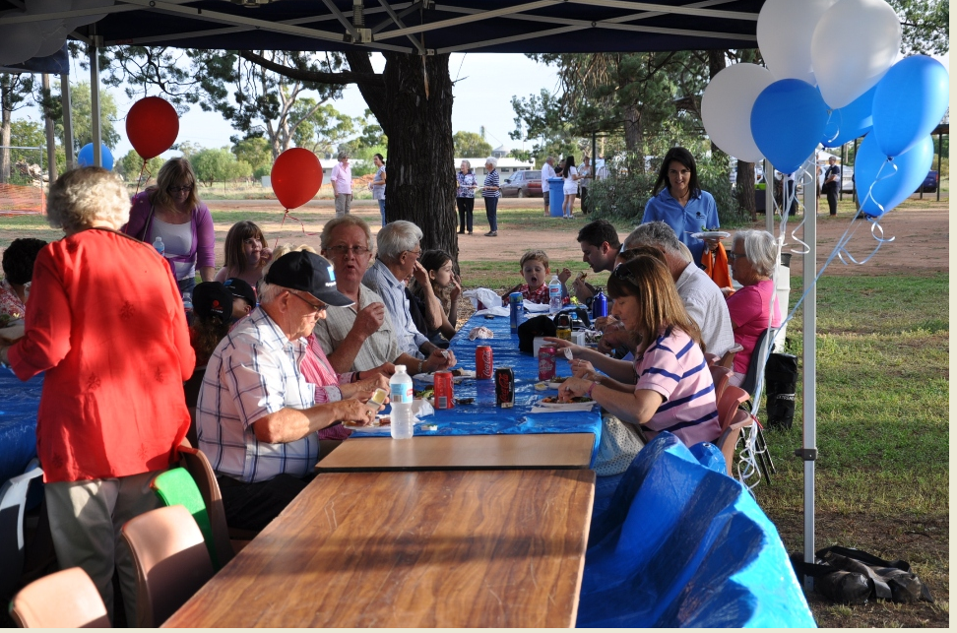
Figure 1 - Nyngan Camp Open Day

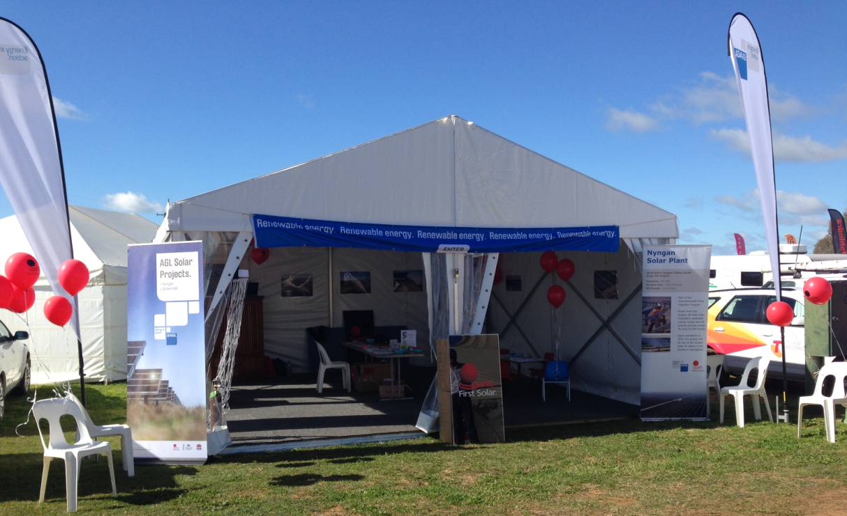
Figure 2 - Nyngan Ag Show
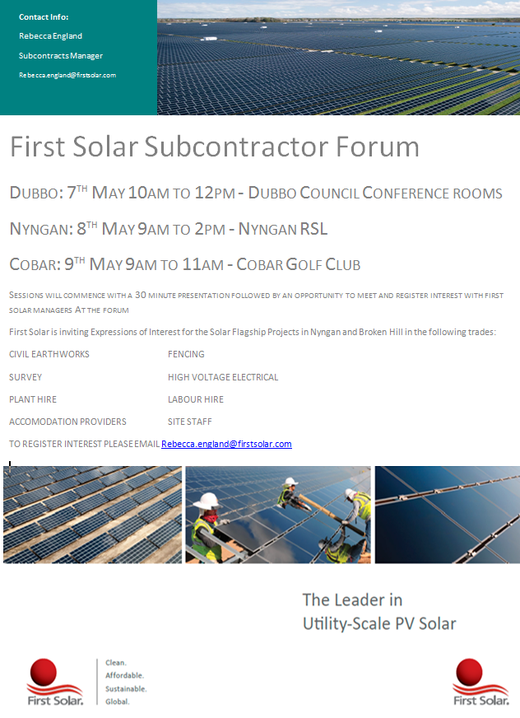
Figure 3 – First Solar Subcontractor Forum Promotional Flier

